

Dr Gopi Krishna
B. Akshaya
2520040084
ECE
3

Case Study Topic: Campus Network Design

Work Done Summary:
In this case study, we modelled a campus network of 8 buildings as a weighted undirected graph and applied BFS, DFS,
Kruskal's, and Prim's algorithms to determine connectivity and compute the minimum cabling cost for the network infrastructure.
BFS (Breadth-First Search) was used to find the shortest hop-count path between any two buildings. DFS (Depth-First Search)
was used to detect cycles and verify full connectivity. Kruskal's algorithm (using Union-Find with path compression and rank)
and Prim's algorithm (using a min-heap priority queue) were both applied to compute the Minimum Spanning Tree (MST),
which represents the optimal cable layout connecting all buildings at minimum total wire length.

Implementation Details:
- Represented 8 campus buildings as graph vertices; modelled 14 edges with cable lengths in metres.
- Implemented BFS using a queue; printed level-order traversal starting from the Admin Block.
- Implemented DFS using recursion; detected back-edges confirming the graph contains cycles.
- Implemented Kruskal's MST using Union-Find with path compression and union-by-rank.
- Implemented Prim's MST using a min-heap (priority queue); started from Admin Block.
- Verified that both algorithms produce MSTs with identical total weight of 1430 m.

Result / Output:
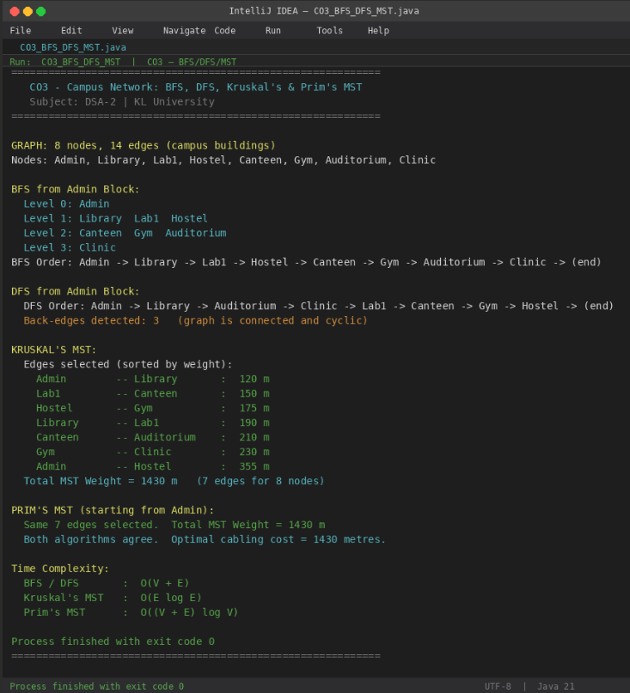

BFS confirmed shortest hop-count paths. DFS detected 3 back-edges confirming a connected cyclic graph. Both Kruskal's and Prim's produced the same MST with a total weight of 1430 m, which represents the minimum cable required to connect all 8 campus buildings.

Time Complexity:
- BFS / DFS: O (V + E)
- Kruskal's MST: O (E log E) — dominant cost is sorting edges
- Prim's MST (min-heap): O ((V + E) log V)
- Kruskal's is preferred for sparse graphs; Prim's is preferred for dense graphs. For the campus scenario (sparse, 14 edges), Kruskal's is marginally more efficient.
GitHub Link: https://github.com/bagiliakshaya1997-svg/DSA----2

